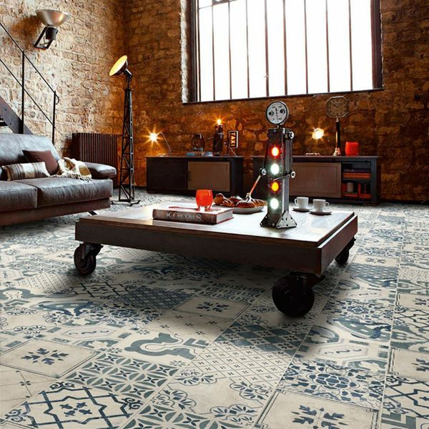**Tangier Antiqua Decor Pattern Floor Tiles:**

## **Product Description**

With a stunning mix of antique patterns, these Antiqua Decor Floor Tiles are perfect for bringing charm and character to your floor spaces. They have a rustic, antique finish, and consist of a variety of different designs ([See here](https://www.wallsandfloors.co.uk/media/uploads/DocumentTangier%20Floor%20Tile%20PDF1403867567.pdf)); ranging from efflorescent displays through to captivating geometric patterns. You'll receive a random mix of the various designs. To take a closer look at one of the pieces, order a full-size sample tile. These stunning floor tiles have a matt design.

## **Product INFO**

* Product ID: 13606
* Tiles Per SQM: 25
* Sale by: Per SQM
* Size: 200x200x9mm
* Weight: 0.80 KG
* Material Type: Ceramic
* Finish: Matt
* Colour: Blue
* Suitability: Floors, Walls
* Grade: 3
* Rectified Edge: No
* Underfloor Heating: Yes
* Document: [View All Designs](https://m2.wallsandfloors.co.uk/media/amasty/amfile/attach/DocumentTangier%20Floor%20Tile%20PDF1403867567.pdf)
* Thickness (mm): 9